Line of Business: Typelists Solution

Exercise 1: Investigation

Answer the following questions about the line of business model in the base application.

1. Which loss type has the largest number of LOB codes?

Liability, which has 4

2. Which policy type belongs to more than one LOB code? What codes does it belong to?

Commercial Package, which belongs to Commercial Property, General Liability, and Inland Marine

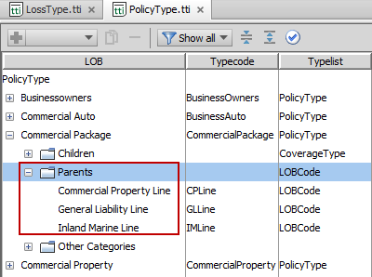

3. Which policy type is retired?

Directors and officers

4. Are any coverages shared by both the General Liability and Professional Liability policies?

No.

5. Compare these two coverages: "Farmowners " and " Earthquake". Do they both map to the same number of exposure types? Do they map to the same exposure type?

Farmowners maps to two exposure types, Earthquake to one exposure type. They each map to the PropertyDamage exposure type.

6. View the General Liability coverage. It maps to nine coverage subtypes, but it maps to only four exposure types. Why do you think this coverage maps to a multiple exposure type in more than one way?

The four exposure types are: GeneralDamage, BodilyInjuryDamage, MedPay and PropertyDamage.

The General Liability coverage is probably a complex coverage. When creating an exposure that uses this coverage, the exposure must not only capture information about the damage, but it must also capture information about the circumstance, possibly because something like the coverage limit varies based on the circumstance.

**Exercise 2: Configuration**

Configure ClaimCenter to meet the following customer requirement from Acme Insurance.

**Requirement 1: Earthquake Coverage Does Not Map to Content Exposure Type**

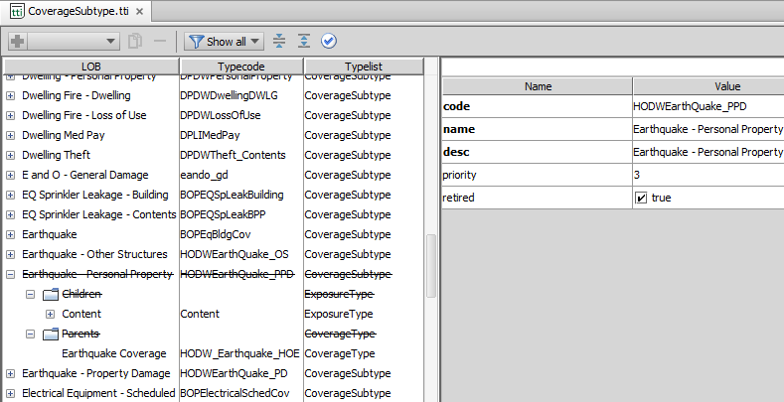  
Note: You may experience an error in Studio – if so, this particular error can be ignored: **8:17:29 AM InvalidVirtualFileAccessException: Accessing invalid virtual file: file://C:/Guidewire/ClaimCenter/modules/configuration/out/classes/extensions/typelist/CoverageSubtype.ttx: Accessing invalid virtual file: file://C:/Guidewire/ClaimCenter/modules/configuration/out/classes/extensions/typelist/CoverageSubtype.ttx**

**8:17:57 AM Compilation completed successfully in 29 sec**

**Requirement 2: New Erosion Coverage**

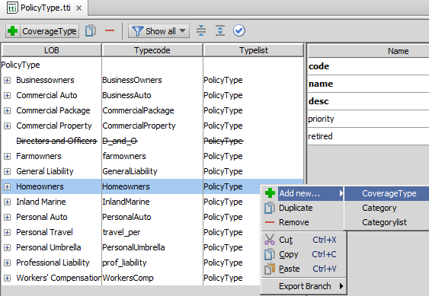

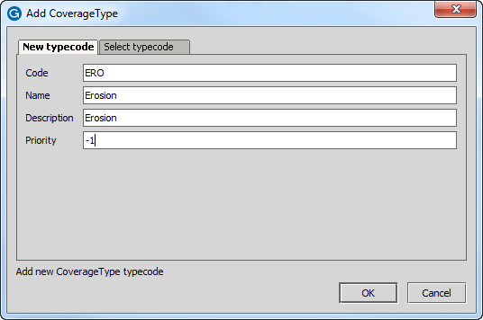

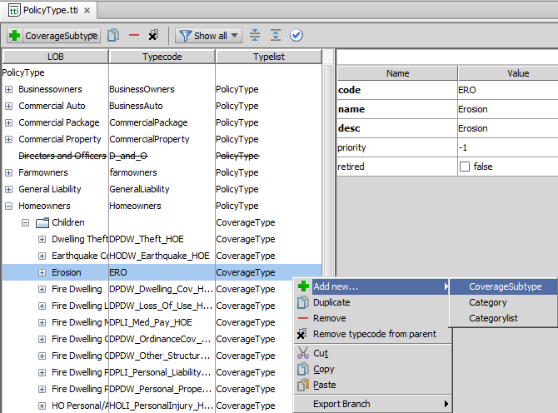

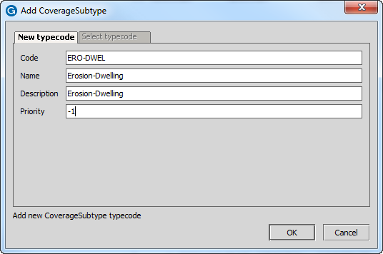

Click Save after creating your Coverage Subtype.

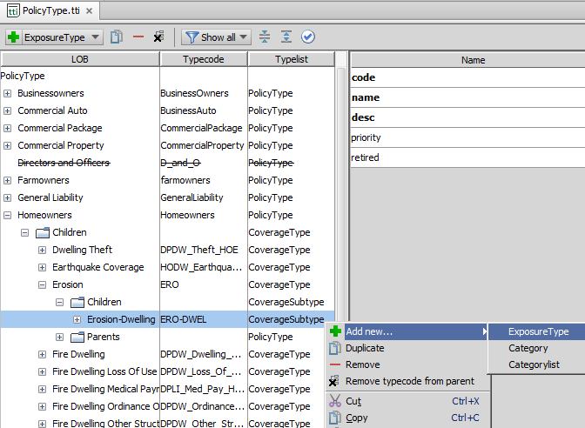

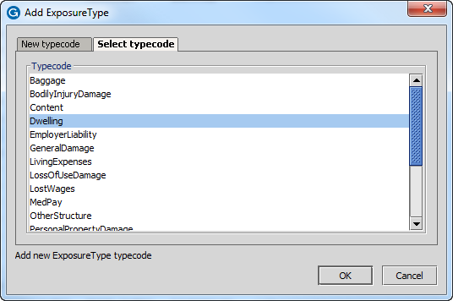

Click Save after mapping ERO-DWEL to the existing Dwelling Exposure Type.

**Requirement 2A: Completing the Erosion Coverage**

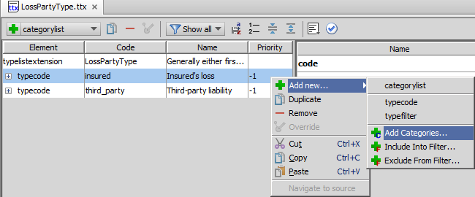

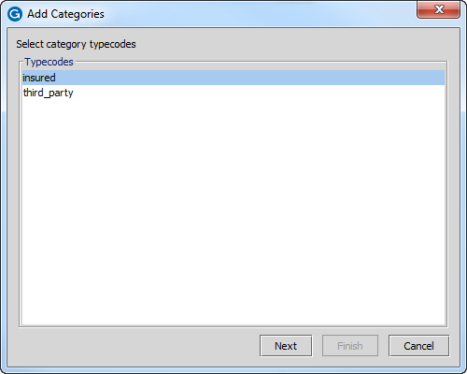

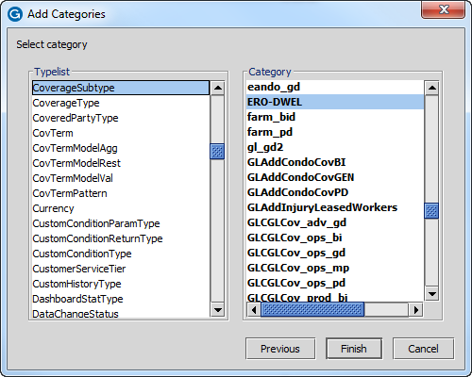

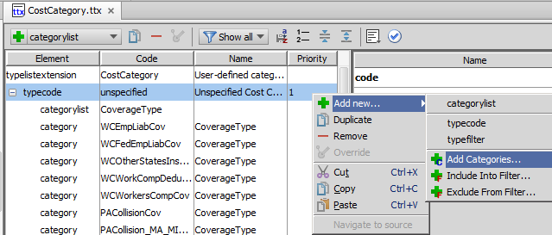

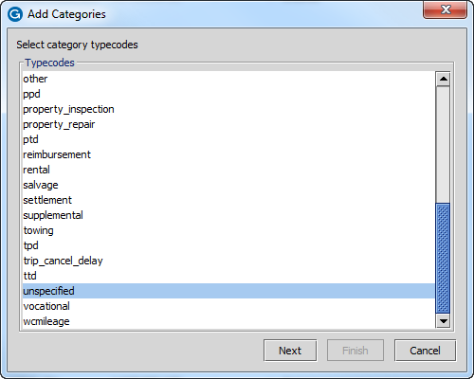

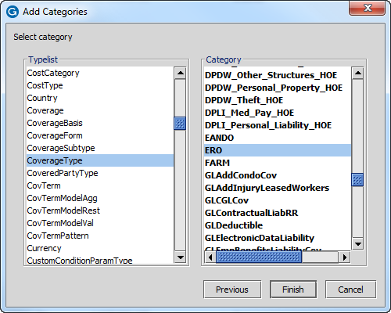

(repeat for labor, mileage, other in CostCategory.ttx)

**BONUS  
Requirement 3: Removing the "Extra Expenses" Coverage**

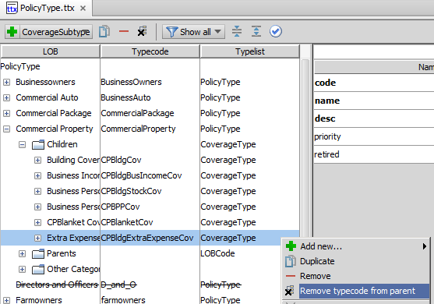

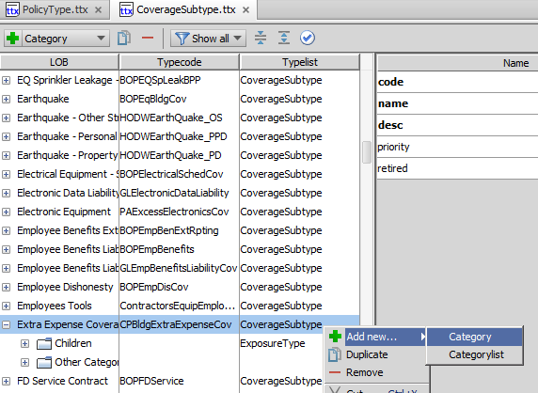

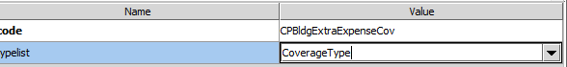

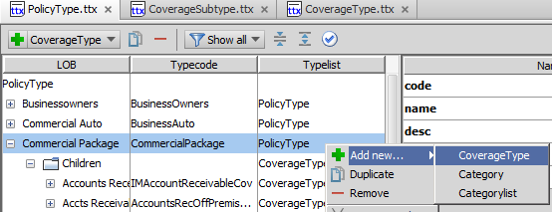

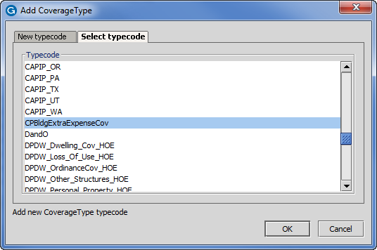

NOTE: After this step above, you may have to add a category to the Extra Expense CoverageType. If there is no parent of the Extra Expense Coverage type, add the PolicyType of Commercial Package as a category to the Extra Expense CoverageType. The result is like so:

